Specialised Plant Cells
Name: ______________________

Adaptations: ___________________________________________________________________________________________________

Function: ___________________________________________________________________________________________________
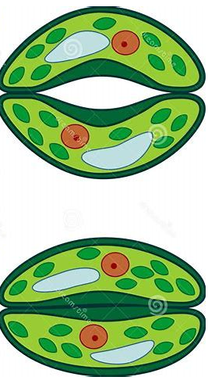
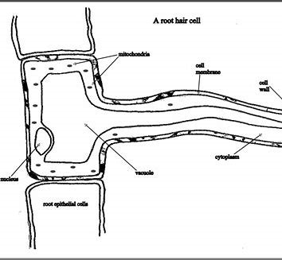
Name: ______________________

Adaptations: ___________________________________________________________________________________________________

Function: __________________________________________________________________

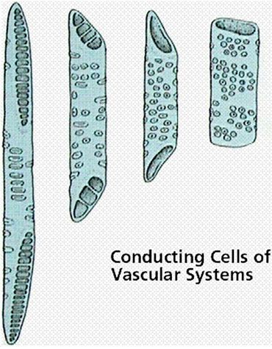
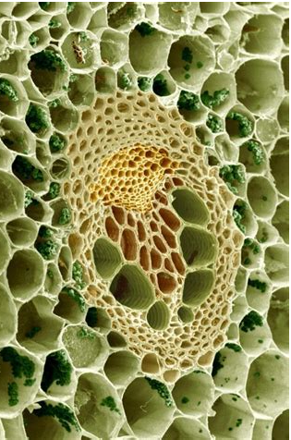
Name: ______________________

Adaptations: ___________________________________________________________________________________________________

Function: __________________________________________________________________
Name: ______________________

Adaptations: ___________________________________________________________________________________________________

Function: __________________________________________________________________

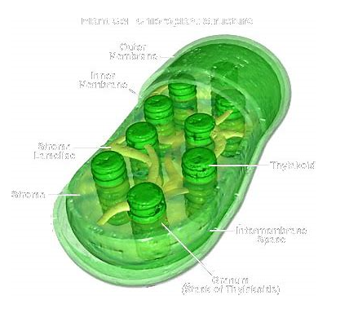
Name: ______________________

Adaptations: ___________________________________________________________________________________________________

Function: __________________________________________________________________
Name: ______________________

Adaptations: ___________________________________________________________________________________________________

Function: __________________________________________________________________

